# **Deliverables for <TTKI - Tulis Tulis Karya Imajinasi>**

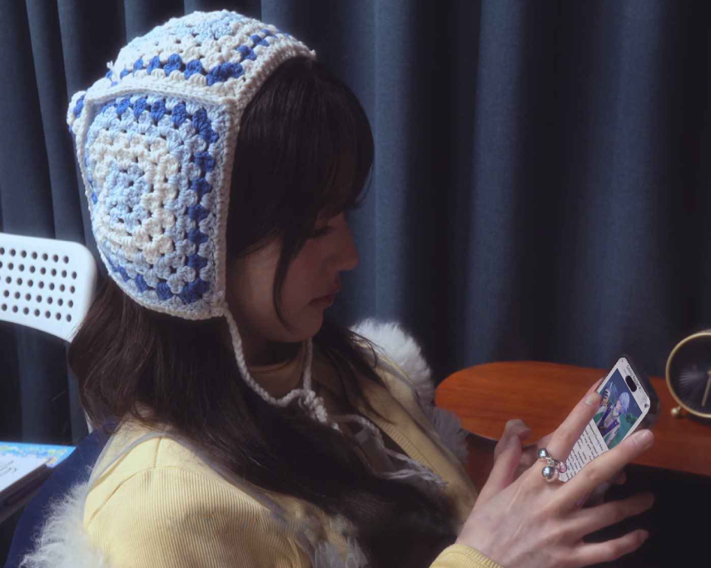

by

**Lydia Gracia (18222035)**

# **ComeBit**

As a STEI student who’s juggling numerous assignments and projects, you often turn to **IVY**, a popular girl group that emerged from the vibrant K-POP scene, for a refreshing break. The six members each have their own unique charm, and watching them never fails to bring a smile to your face.



IVY

You've been hoping to meet them in real life instead of just watching through a flat screen, as you’ve done up until now. And soon, your dream is about to come true! You’ve already secured a ticket to the festival section of the upcoming IVY concert, **‘A LEAGUE OF MY OWN’**.For the first time ever, they’re performing at your university’s hall, Sasana Budaya Ganesha. ITB students even get easier access and discounted tickets ~~(let a girl dream)~~.



Sasana Budaya Ganesha

The concert is still two months away, but you’re already excited every day. Like other die-hard fans, you blast their music daily, practice the fan chants, and plan outfits to impress the girls. You’re going for a school-uniform theme to match **Vicky**, your favorite member who you especially adore.



SDFHSDJAFHDSKAKJSVICKYYYYY

Today is just another day, another night where you plan to stay up late to catch up on deadlines ~~(skill issue)~~. The clock reads 21:58. You decide to take a ‘quick’ break to scroll through X. Actually, you’re just waiting for 22:00, when IVY is set to drop something for their upcoming comeback.

“Today is… the highlight medley. Yeah!”

You check the comeback schedule they posted a week ago. You get ready by loading their YouTube channel on your laptop and their X account on your phone. You also plug in your headphones, ready to blast the snippet at full volume.

“3... 2… 1…”

It’s finally 22:00 sharp. Their X hasn’t posted anything yet, but there’s a strange new video up on their YouTube channel. The title doesn’t seem related to the comeback, but curiosity gets the best of you, and you click on the 0-view video.

“Srrk… Srrk…”

The video looks like leaked CCTV footage from IVY’s production room. The quality is terrible, but it shows the members discussing and working on their music. It seems like behind-the-scenes content while they’re producing this album.

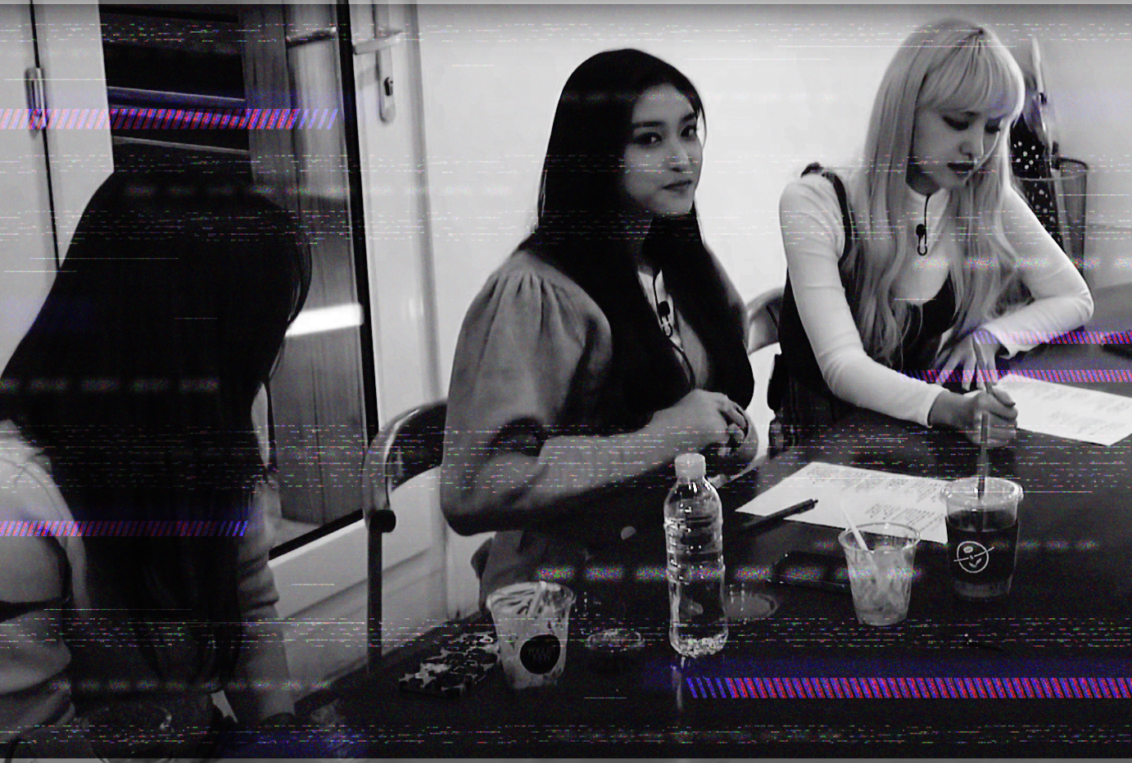

🤡

“What in the world…”

You mutter to yourself. You know this is their first self-produced album, but it’s odd for an M/V teaser to use this concept. It doesn’t match the concept photos they released earlier. You start wondering if there’s a technical issue on their end.

“Ngiiing!”

Suddenly, the video goes completely dark, followed by a long, high-pitched noise that makes your head hurt. Before you can even remove your headphones, your vision blurs and everything goes black as you pass out on your desk.

***

You slowly open your eyes and find yourself in an unfamiliar room. You’re lying on a sofa, and several unfamiliar figures are gathered around a desk across the room, seriously discussing something in hushed tones. The room resembles the CEO’s suite you’ve seen in K-Dramas.

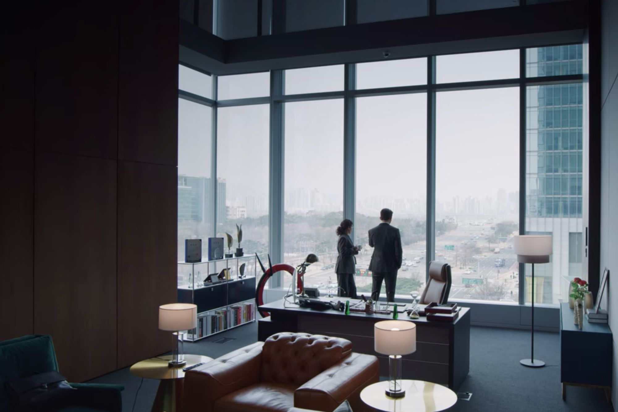

🥶

“W-what.. Where am I?”

“You’ve woken up?”

The figures turn around to face you. To your surprise, some of the faces seem vaguely familiar, though you can’t quite recall where you’ve seen them before. Your head still aches a bit. Before you can gather your thoughts, the unfamiliar person sitting behind the desk starts speaking to you.

He turns out to be the CEO of **SPACESHIP**, the agency that manages IVY. The familiar faces around him are IVY's managers and bodyguards—the ones you've seen in their content. You're still confused and amazed by the fact that you woke up in this room and are casually communicating with these people.

They urgently explain that an unknown entity has been tampering with IVY’s important files. All of IVY’s data has been locked, including their backups. And it’s as if any trace of their existence on the internet has been erased

This mysterious entity sent a strange video to the CEO’s email, warning that they have a limited time before **“*the world’s memory of IVY will be erased forever*”**, which leaves you in shock.

You mention that you clicked on a similar suspicious video on their YouTube channel, but they confirm they never posted anything like that.

“That is strange…”

“I know—it’s hard for me to believe too, but I swear you appeared on that sofa 30 minutes ago right after I read the email. Regardless, I think you’re meant to help us with this challenge. The last sentence in the email… it hinted at your involvement. Please! If you succeed, you’ll get the **chance to meet IVY in person**.”

***

Here you are, sitting in front of one of their PCs in the production room, surrounded by several bodyguards who watch your every move. Thankfully, you have access to the essential resources you need while you’re here. As you examine the files, it becomes clear that you should **manipulate and arrange back various bits in the program**. You ruffle your hair in frustration, knowing you have no choice but to give it your all.



XO, IVY

# **Flash Reverse**

You’re back to your usual college routine, coding in your room while vibing to IVY’s latest album. You feel proud of yourself for resolving that incident two months ago and for bringing IVY’s digital records to the world. It’s strange to think that life just moved on as if nothing happened. But you know it’s real, and every now and then, you remind yourself of it as you gaze at the signed albums and the stack of photocards on your top shelf.



Thee-ultimate-Vicky-photocard-that’s-been-at-top-of-your-wishlist

You’ve had the chance to meet and hang out with the IVY members personally. They are super nice and even more charming in real life. They even gave you some of their merchandise, including a flumffy, gigantic **Cheery** plushie that now sits in the corner of your bed and you cuddle with occasionally on your sleep. You cuddle with it occasionally as you sleep.



🍒

This weekend's concert day, and you’re more ready than ever. The IVY members themselves helped you pick out your outfit and gave you styling tips. You’re also set to meet them backstage after the show. You’ve basically become friends with them. It’s crazy, but you’re enjoying it.

* * *

“... PC check. Wallet check. Okay!”

It’s Saturday, and like many other **Blossoms**, IVY’s devoted fans, you’ve arrived a day early at the venue for the freebies and fun. From the parking lot, you can see banners of the members stretching from the entrance to the main venue. The crowd is large, and you’re beginning to scan the area.

They’re playing a random dance party featuring IVY’s songs. Right now, they’re playing “**Eight**”, their debut track—a classic. Eugene, even though she’s not your bias, was absolutely slaying this song. The crowd of Blossoms is giving their all in their performances, while many others cheer them on from the sidelines. However, you’ve decided to join in later because the freebies tend to run out quickly.



Slayyyyyyyyyyyyyujin

* * *

You’re about to go claim the last freebies on your list when someone bumps into you. This person is tall and appears to be in a hurry. They quickly gesture an apology before disappearing into the crowd. You didn’t even get a chance to say anything.

“Eh, what’s this?”

You notice a flash drive on the ground. You’re pretty sure it must have fallen from the person who bumped into you, since there wasn't anything near this spot when you tied your shoelace earlier. You sigh, thinking you’ll have to bring it to the lost and found.

Just then, your phone rings. It’s IVY’s manager. You answer quickly, expecting it might be a confirmation call for tomorrow’s concert or something similar.

“Hello? Are you near the venue right now? It’s urgent…,” her voice sounds worried.

“Oh, yeah, actually I am. I’m here picking up freebies and meeting friends. Is there anything I can help with?”

“Oh my God! That’s great! Can you please come to the second entrance on the left wing as soon as possible? Someone tampered with the media again. See if you can do anything about it, please.”

* * *

You’re now sitting backstage with the concert’s computer in front of you. Just as the manager said, the visuals for the concert are missing. You’ve checked the bin, but nothing related can be found. Frustrated, you ruffle your hair.

“Again? Isn’t there any backup?”

“We’re contacting headquarters right now, but if it’s the same attacker as last time, the backup might be erased too! I called you out of panic. I’m really sorry,” she whispers, clearly anxious and trying to keep the previous incident a secret.

“I hope there’s a backup... There’s no pop-up or anything here. I don’t know what to do, but I’m still figuring it out.”

She nods, apologizing for the panic, and quickly excuses herself to take a call. You start scanning the backstage area for any clues, feeling like you’re playing Sherlock Holmes, even though you’re not entirely sure what you’re doing.

“It’s kind of impossible to sneak in here, unless someone could magically teleport in and out, then escape the crowd in a flash. Wait, teleport... Flash...”

You might have just had your Eureka moment. You immediately request a spare laptop that they’re ready to let go, just in case the flash drive you found earlier contains a virus.

* * *

You nervously plug in the flash drive. Thankfully, it doesn’t seem to contain any viruses. Instead, there is one (1) folder on it.

“It’s the folder! The name.. I’m sure of it! Can you check it out? Where did you get this?”

The manager sounds surprised. You explain what happened, then begin browsing through the folders. Instead of finding the missing videos, you come across a bunch of numbered folder containing executables and a readme file that reads:

“It’s my second challenge for you. You know what to do. **Reverse engineer** it and we’ll have a deal. I know you’ll solve it, just like last time, right? But, oh, it seemed too easy for you then. So now, please **be careful of the land mines** I’ve planted there. :)”

“Oh not again!”